FOUNDATION FOR VIRTUAL AND AUGMENTED REALITY SYSTEMS
Lecture29
Lec-29: Auditory Sense & Immersive Experience
Hello and welcome to the NPTEL MOOC's course on Foundations for Virtual and Augmented Reality Systems. We are going to start a new topic on auditory senses and immersive experiences. So, earlier we started our discussion with interactive systems, how they are important, how user behavior characteristics are important to deal with interactive systems, to design better interactive systems, to design usable interactive systems. And in that context, we introduced the idea of human factors that influence the design and overall experience of interactive systems.
The human factors that are relevant for extended reality systems, we have gone through basic ideas on those and subsequently we started our more detailed discussion on individual human factors that are relevant for extended reality experiences. In the previous lecture, we talked about our visual senses, physiology of vision, and how that knowledge helps us build better display devices or make design decisions when dealing with virtual reality experiences.
In this lecture, we are going to talk about, in a similar vein, we are going to talk about auditory senses, our auditory sense and physiology of our hearing, and how that is relevant for extended reality experiences. So, essentially we will be covering basics of the human auditory system and how they help immersive experiences in XR. In particular, our focus will be on VR because VR is more relevant for immersive experiences.
So, first let us try to understand the role of audio in extended reality experiences. If we think of it, generally when we talk of extended reality experiences, immediately Things that come to our mind are mostly related to our visual sense. And that is true with the developers as well. So, developers tend to focus mainly on vision, which is our strongest sense, so to speak.
And most thought about sense. But, Vision is not the only sense that influences our experience with extended reality systems. There are other senses; we have already gone through those senses, five senses plus one sixth sense that is proprioception. We talked about those.
So, one of those other senses is the audio or auditory sense. So, the audio component of virtual reality is also very powerful in providing an immersive experience. And there are technologies that exist to bring high fidelity audio experience into VR. And if we make use of those technologies, then clearly our immersive experience will improve. Audio recording, recording of sound, speech or non-speech sound, and reproduction, that is output generation, can be considered a VR experience in itself.
Even if other senses are missing. And that experience can be relevant for both cave-like versions, that is the surround environment, environment surrounded by display devices, where this audio recording and reproduction can provide better effect, surround sound effect, And even in the headset version, that is the wearable display version, there also the audio recording and reproduction can provide a better immersive experience. In fact, when we combine sound with the vision or visual effects, then that affects our perception of the virtual environment such as size, volume, material, intensity, distance, and so on.
Note that Our general thinking is that just by looking at it, we will be able to get an idea of the distance or the size or the volume, material, and so on. That is partly true. The perception, the understanding of those properties of the objects that surround us, gets reinforced when our vision is augmented with auditory effects. So, when we are trying to deal with immersive experience, our objective should be to include as many senses as possible.
Only visual sense may not give us the full picture of our surroundings. So, that will, in a sense, affect our immersive experience. If we augment vision with audio, that will enhance the immersive experience. So essentially, audio helps reinforce our experience as believable. That means it is closer to reality, closer to our everyday experiences.
It can help create emotional connection with the environment. Only vision may not be able to do that. Vision coupled with audio can help. Increase our emotional connection with the environment. Overall, they are very important to maintain presence because presence requires both reinforcement of our virtual experience as believable as well as developing some attachment to that experience.
So, overall auditory experience plays a very important role in increasing our presence. In the virtual environment. So that is why we should be concerned with generation of or dealing with audio in virtual reality experiences. Now, like we did before for vision, let us try to first understand the basics of sound and human experience. Physiology that allows us to perceive sound and then we will see how that knowledge can be useful for VR experiences, for designing better VR experiences.
So, first let us start with the basics of sound. Most of us may already be aware of it, but like before, it is always better to recap our basic knowledge. So that subsequent discussions are understandable. Now, what is sound? Sound is nothing but vibration in a medium and that medium is usually air, but could also be some other medium such as water or any other gases, liquids, and solids.
So, it requires some medium and Sound always propagates through a medium unlike light which may propagate without any medium as well. So, there is no sound in a vacuum unlike light propagation which can propagate through vacuum. Now, molecules in the medium get displaced causing variation in pressure which ranges from compression extreme, that is when the pressure is extremely high, to decompression extreme or decompressed, which means
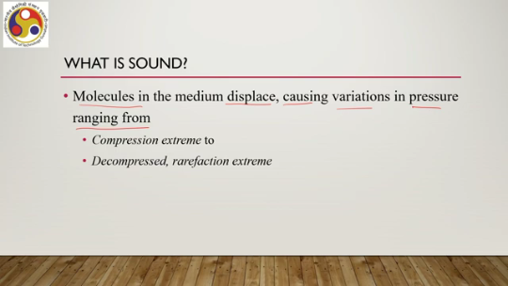
The pressure is very low; that is also called rarefaction extreme. So, essentially when sound is generated, that creates pressure differences in different parts of the medium. ranging from compression extreme to decompression extreme, and that is the mechanism which allows sound to propagate through the medium. So, at a fixed point in space, that is within the medium, pressure varies as a function of time. The same is applicable in the case of the human eardrum.
Pressure variation can occur on a human eardrum which is converted into a perceptual experience that we consider to be auditory experience. Now this brings us to the representation of sound for better understanding. So we can represent sound in the form of a sound wave. So which is nothing but a plot of pressure variation against time. So as you can see in this accompanying figure, the x-axis represents time, the y-axis represents air pressure.
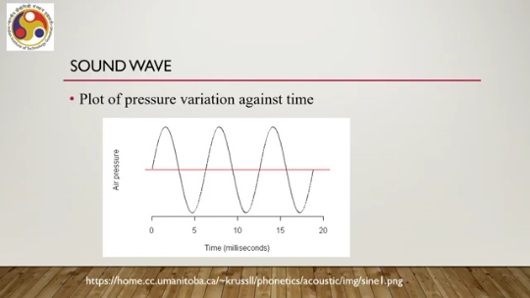
So as time progresses, the pressure varies from one extreme to another and it goes on like this, like a sinusoidal wave. And that representation we can consider to be representing sound. So, since we can represent sound as a wave, we can utilize wave properties to characterize sound. So, properties of sound as a wave, there are many such properties that we can utilize for various purposes. So, the first thing is frequency.
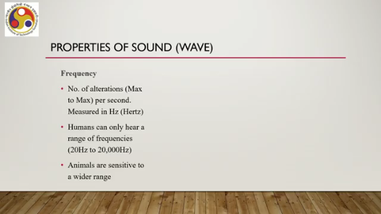
Like a wave, sound can also be considered to have a frequency, which is the number of alterations between one maximum to another maximum per second, which is measured in Hertz. The unit is Hertz. Now, the human ear is designed to hear only a range of frequencies generated by sound waves, which varies from 20 Hertz to 20,000 Hertz. Anything between this range is audible
to a human ear and anything outside this range is not audible to a human ear. However, that is the limitation of human physiology, but other animals can perceive a higher range outside this audible range of humans. So, that is frequency. Another property is amplitude. which is like any other wave, which is defined as the maximum displacement from the mean or rest position of the wave.
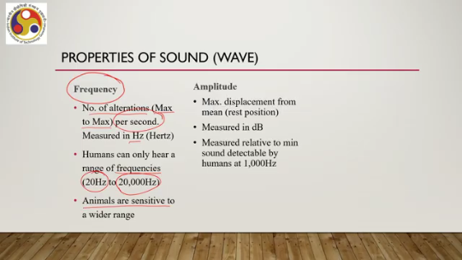
It is measured in dB or decibel and measured relative to the minimum sound detectable by humans at 1000 Hz. So, this is the second property amplitude. Third is phase. It is the start position of a cycle, a cycle of the wave, where it can begin at 0 to 360 degrees and is measured in degrees. So, we have primarily these three properties that are relevant for dealing with sound waves: frequency, amplitude, and phase.
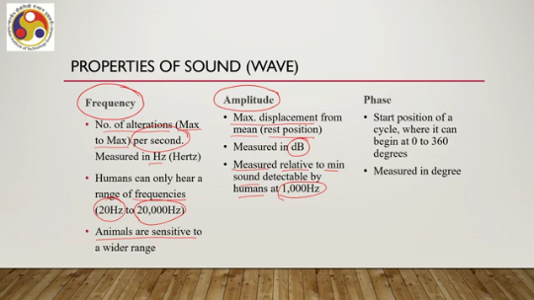
Now, with that basic knowledge of sound, let us now shift our attention to the human auditory system or the physiology of the human auditory system. Probably, as before, we have encountered this in our high school days, the physiology of human hearing, but there is no harm in recapping the earlier knowledge. So, the human hearing system contains three parts. Now, what are these three parts? Outer ear, middle ear, and inner ear.
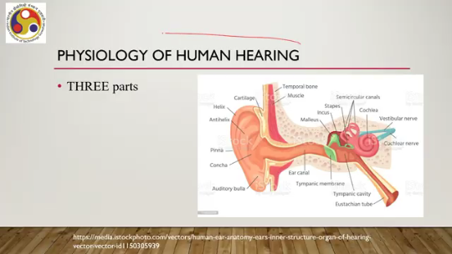
So, we have three parts of the human hearing system: outer ear, middle ear, and inner ear. This part we can call the outer ear. Middle ear here and inner ear here. So, let us start with the outer ear. There are a lot of components in our auditory system.
A crucial one is the canal. This canal works as an amplifier, boosting the sound pressure for a range of frequencies. So, this is the receiver part, and then it receives the wave, then forces it to propagate through the canal which amplifies the wave, which is part of the outer ear. And because of the kind of folds that are there, the complex folds attenuate high frequencies. So, if there are some high frequency sound waves appearing, then due to the design of our canal and the receiver, the high frequencies get attenuated.
Then comes the middle ear. So, once the wave passes through this canal at the outer ear, it then strikes the tympanic membrane causing vibration. This is the tympanic membrane. So, the wave hits this membrane causing the membrane to vibrate. Now, this vibration then transfers to three bones which are part of the middle ear.
Also known as ossicles that are housed in an air-filled chamber, namely malleus, incus and stapes. So, these three are shown here: malleus, incus and stapes. So, these three bones are part of the middle ear. And finally, we have the inner ear. Now, this is the size of a marble which houses a component or an organ known as cochlea which is the sense organ for hearing.
This is the cochlea. This is part of the inner ear. Now, it converts sound energy to neural impulses. So, the cochlea is connected with nerves or neurons. And it converts the sound energy, that is the wave that is coming to it through the various mechanisms, to neural impulses to be transmitted to the brain through the neural network.
So, in summary, what we can say is that, in this part of the lecture, we have covered two important things. That is, why sound is important. Just to recap. Most emphasis typically is given to our visual senses while dealing with virtual reality or any immersive experience. Visual senses are important, of course, and corresponding design of the display device is very important.
However, to get a better perception of the virtual world, to have a higher presence, to get a better idea of the kind of objects that are there, their size, distance, orientation, position, volume. Vision accompanied by sound is always preferable. And in that sense, we should think about including auditory stimuli to excite our The hearing system so that we get a better immersive experience and there are already technologies that exist to give us better immersive experiences.
Now to understand how to do that, we started our discussion with the basic idea of sound, which is nothing but a wave, and With this definition of sound as a wave, we can understand how our auditory system works. So, our ear contains three parts: outer ear, middle ear, and inner ear. Sound waves get converted to neural impulses through the mechanisms that are there in these three parts of the ear and finally get transmitted to our brain for perception. So, how ears are made we have also discussed on those.
In the latter part of the lecture, we will learn about how we perceive sound and how we render sound to get the best experience. So, we will continue our discussion in the next lecture. So, I hope you were able to follow the lecture and understand the concepts. Looking forward to seeing you in the next lecture. Till then.
Thank you, goodbye and happy learning.

